M.A. Jones Elementary School

Date: February 11, 2025

Time: 4:04-5:27pm

Location: Zoom

1. Call to Order: 4:04pm
2. Roll Call

|  |  |  |
| --- | --- | --- |
| Role | Name (or Vacant) | Present or Absent |
| Principal | Teruko Dobashi | Present |
| Parent/Guardian | Ayana Dunston | Present |
| Parent/Guardian | Meghan Plumb | Present |
| Parent/Guardian | Krista Verdelotti | Present |
| Instructional Staff | Anthony Missick | Present |
| Instructional Staff | Cole Pryor | Present |
| Instructional Staff | Ladeandra Scott | Present |
| Community Member | Jilo Tisdale | Absent |
| Community Member | Raquel Hudson | Present |
| Swing Seat | William Oliver | Absent |

Quorum is met.

1. Action Items
   1. Approval of Agenda

MOTION: Pryor

SECOND: Plumb

RESULT: Motion passed unanimously

* 1. Approval of [Previous Minutes](https://docs.google.com/document/d/1udAuVsHJ0w_kmnepaQGDDoSyIzyfDgVn/edit) of January 2025

MOTION: Pryor

SECOND: Ayana

RESULT: Motion passed unanimously

* 1. Approval of [Previous Minutes](https://docs.google.com/document/d/1XxFIAPXpPt83lbSjvuevRJsU1ZOkGxk0/edit) of December 2024

MOTION: Plumb

SECOND: Missick

RESULT: Motion passed unanimously

1. Review of previous Discussion
   1. Strategic Plan Update

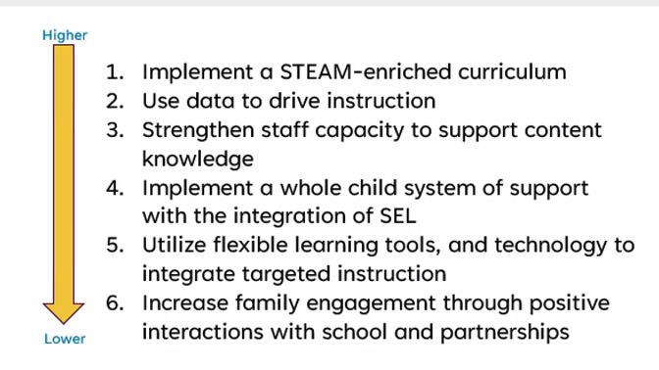

* 1. Strengthening our staff is vital, 34% have 3 years or less of experience.
  2. Signature Programing Requested vs Approved

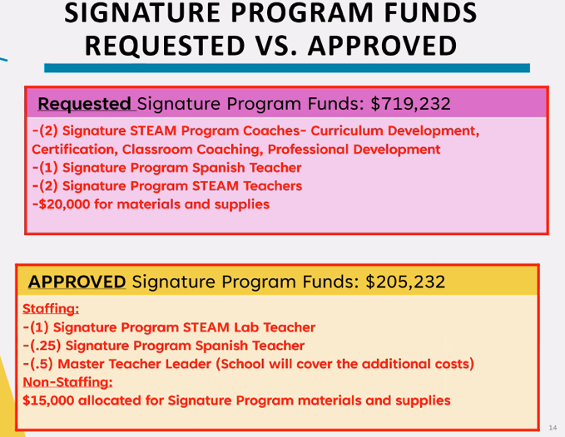

* 1. Teacher to Student Ratio:
     1. Grade K & 1 1:24
     2. Grade 2-3 1:27
     3. Grade 4-5 1:30

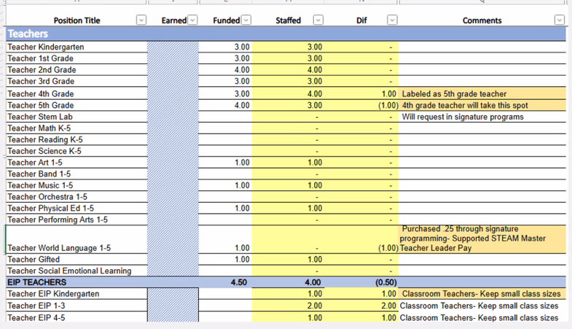

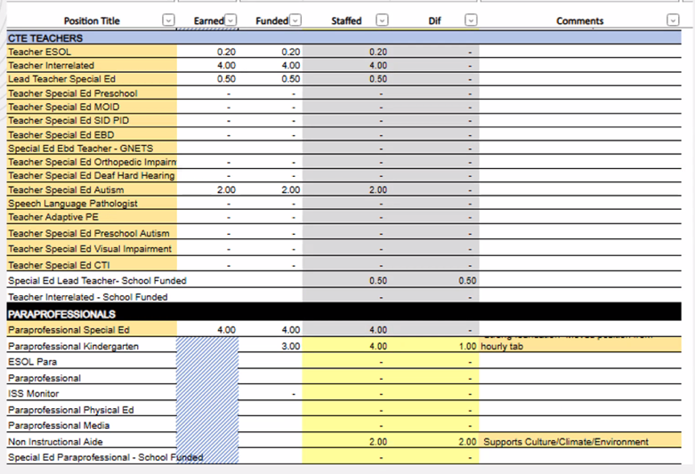

* + 1. All paras for Kindergarten are NO longer hourly; Fully staffed para’s for Kindergarten.

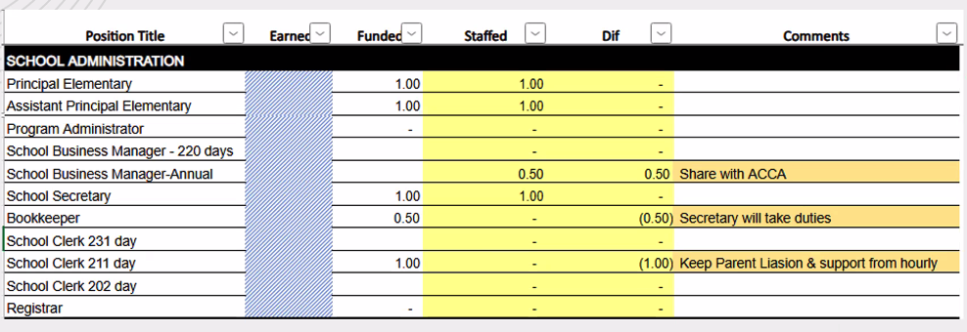

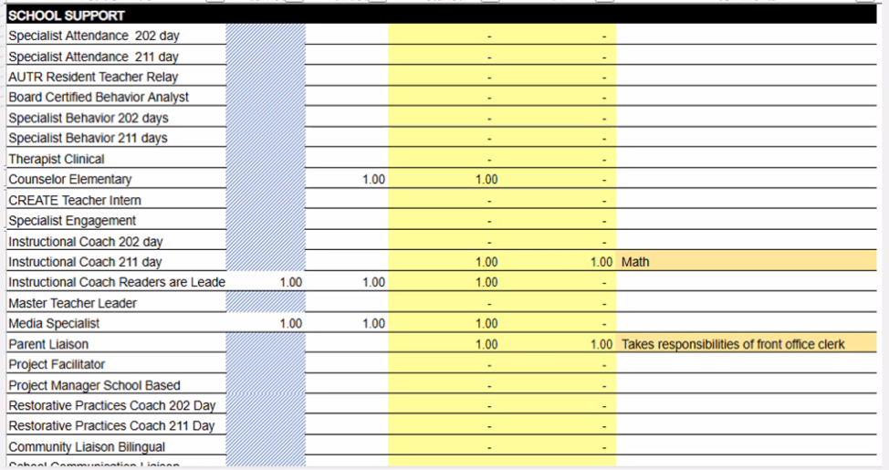

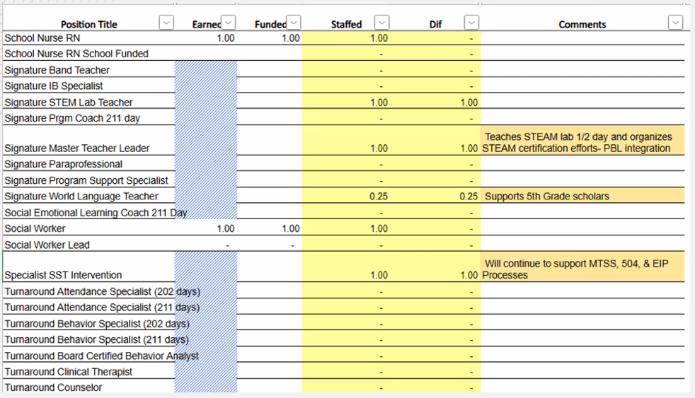

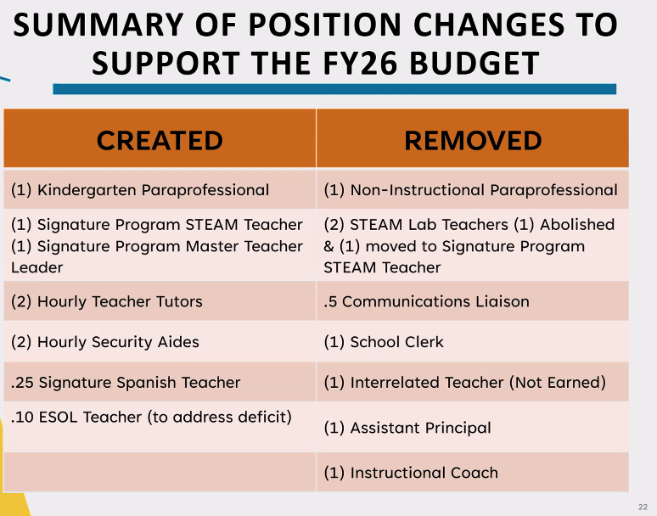

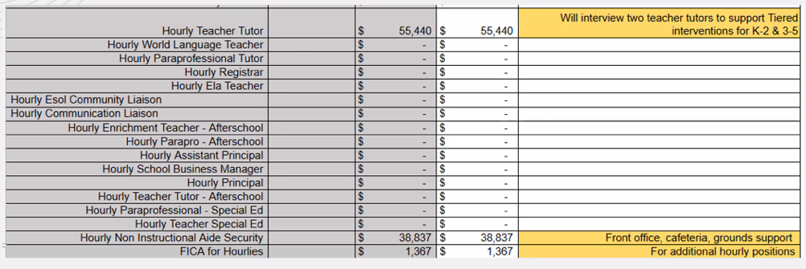

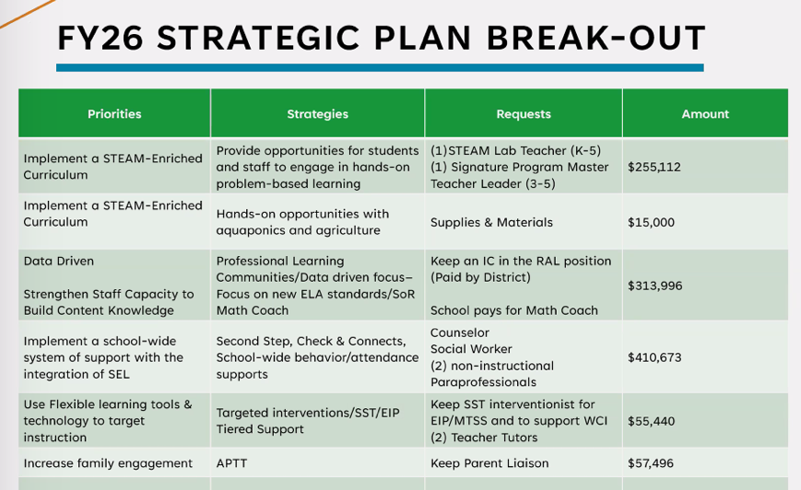

(52 minute mark)

* + 1. 1 AP will support instruction for K-5, some discipline, and management (split with business manager).
    2. Business Manager: EPAT, Evaluate with TEAK, facilities, ordering, budget, time sheet, anything HR (they’re the in between APS HQ and school)
    3. Secretary: manages funding from partners, specialized revenue, time keeper, scholar registration, all records are kept for scholars.
    4. Parent Liaison: works in front office, liaison between parents and the school, communication roles too
    5. MAJ has a $400K deficit.
    6. 2025-2026 (Possible reserve) $106,176

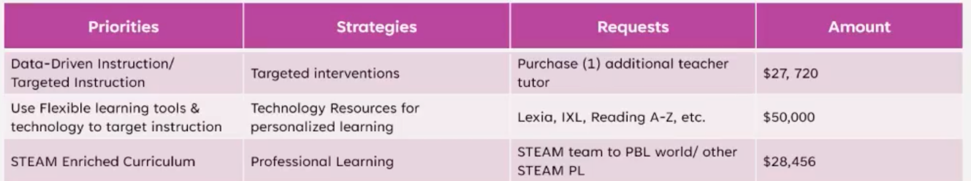

* + 1. MAJ Next Meeting: March 11, 2025
    2. Projected enrollment for 2025-2026: 433
       1. 2024-2025: $5,334 per pupil (1 hour and 12 minute mark)
       2. 2025-2026: $6,007 per pupil
  1. APPROVAL OF BUDGET

MOTION: Verdelotti

SECOND: Pryor

RESULT: Motion passed unanimously

1. Information Items
   1. Principal’s Report (1 hour and 14 minute mark)
      1. STEAM recertification process
         1. COGNIA should receive validation by end of March 2025.
         2. GADOE Recertification Informal Visit Thursday, January 28, 2025.
            1. Met yesterday with GADOE & received action steps with intentionality with PBL, art integration vs. art enhancement, and our students journals how they’re put together.
            2. MAJ will resubmit paperwork May 2025. MAJ will NOT receive certification for 2025-2026 school year.

MAJs certification ends in May 2025.

GADOE will visit Fall 2025.

* 1. Uniform Committee
     1. Meeting with Students in early February 2025.
        1. More colors for uniform top.
        2. 5th graders want a different color than the lower grades.
           1. K-2
           2. 3 & 4
           3. 5th
        3. Monday & Friday as “Free Days”
     2. Follow up meeting, this Thursday February 13, 2025.

1. Announcements (@ 1 hour 52 minute mark)
   1. Scott: GOTeam Budget training
      1. Dobashi: [Positions Available](https://www.atlantapublicschools.us/domain/15150) declare by February 28, 2025
         1. [1 parent seat](https://form.jotform.com/electionbuddy/2025-spring-go-team-declarations)
         2. 1 staff seat
         3. [1 swing seat](https://www.surveymonkey.com/r/candidatebank)
2. Adjournment
   1. MOTIONED: Pryor
   2. SECONDED: Missick
   3. RESULT: Motion passed unanimously

ADJOURNMENT at 5:27 PM

--------------------------------------------------------------------------------------------------------------------------

Minutes Taken By: Krista Verdelotti

Position: Secretary

Date Approved: